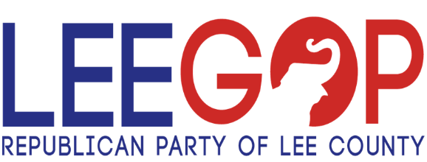
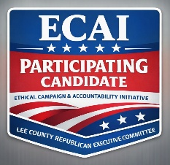

Noncompliance & Enforcement Policy
LEE COUNTY REPUBLICAN EXECUTIVE COMMITTEE (LCREC)
Ethical Campaign & Accountability Initiative (ECAI)

I. PURPOSE
The ECAI Enforcement Policy establishes a clear, structured, and enforceable process for addressing violations of ethical campaign standards. This policy ensures fairness, due process, and transparency while maintaining the integrity of the Republican Party and public trust.

II. REPORTING & VERIFICATION
All alleged violations must be submitted through official ECAI reporting forms and must include specific, verifiable evidence. Anonymous, speculative, or unsupported claims shall not be considered.
Upon receipt:
- The Ethics Subcommittee shall conduct a preliminary review within 48 hours
- A determination of credible evidence is required before proceeding

III. ENFORCEMENT PROCESS (THREE-TIER SYSTEM)
Tier 1: Confidential Notice (Opportunity to Cure)
- Candidate is notified privately of the alleged violation
- Notice includes specific findings and required corrective actions
- Candidate shall have 3 calendar days to respond or cure
- Matter remains strictly confidential

Tier 2: Formal Finding (Escalation)
- Initiated upon failure to cure or inadequate response
- Candidate receives a written formal determination of violation
- Required to submit a remediation plan within 3 days
- Compliance must occur within 7 days of formal finding
- Documentation maintained in official ethics file with limited Board access

Tier 3: Public Disclosure (Enforcement & Accountability)
- Triggered upon failure to remediate within prescribed timeframe
- LCREC may publicly disclose:
  - Nature of violation
  - Candidate response (or lack thereof)
  - Final determination
- Candidate status may be designated as:
  - Non-Compliant
  - ECAI Status Revoked

IV. ECAI BADGE REVOCATION & REQUIRED REMOVAL
Upon a determination of Non-Compliant status or revocation of ECAI participation, the candidate shall:
- Immediately cease all use of the ECAI Participation Badge
- Remove the badge from all campaign materials, including but not limited to:
  - Websites and digital platforms
  - Social media accounts
  - Printed materials and mailers
  - Advertisements, endorsements, and public communications
Mandatory Compliance Timeline:
- Removal must occur within 48 hours of official notice of revocation
Failure to Comply:
- Continued use of the badge after revocation shall constitute unauthorized and misleading representation
- LCREC reserves the right to:
  - Publicly disclose improper badge usage
  - Issue formal notice of misrepresentation
  - Take additional actions deemed necessary to protect the integrity of the Initiative

V. STRUCTURED REMEDIATION REQUIREMENTS
To restore compliance, the candidate must complete all of the following:
- Public Acknowledgment
  - Must acknowledge violation within 72 hours of formal finding
- Written Remediation Plan
  - Submitted within 3 days, outlining corrective measures
- Corrective Implementation Timeline
  - Standard remediation period: Up to 21 days to complete corrective actions and submit supporting documentation
Accelerated Election Period Provision:
  - If a violation occurs within 14 days of a Primary Election, the Ethics Subcommittee shall impose an expedited remediation timeline not to exceed 7 days total, including all corrective actions and documentation
  - The Subcommittee may further shorten deadlines as necessary to ensure timely voter awareness and integrity of the electoral process
- Verification Review
  - Ethics Subcommittee review and/or Board confirmation
  - Final determination issued:
    - Good Standing Restored
    - Conditional Compliance
    - Non-Compliant (Maintained)

VI. EXPEDITED ENFORCEMENT (IMMEDIATE ESCALATION)
The Ethics Subcommittee reserves the right to bypass Tier 1 and proceed directly to Tier 2 or Tier 3 in cases involving:
- Knowingly false, deceptive, or defamatory campaign communications
- Violations of applicable law
- Fraudulent or materially misleading representations
- Repeated or intentional misconduct

VII. FINAL STATUS DESIGNATIONS
Candidates shall be publicly classified as one of the following:
- ECAI Certified (Good Standing)
- Conditional Compliance
- Non-Compliant / Revoked
- Declined Participation

VIII. GOVERNING PRINCIPLE
This policy is designed to promote ethical conduct, accountability, and public confidence. While candidates are afforded a reasonable opportunity to correct violations, failure to comply will result in transparent enforcement to uphold the integrity of the electoral process and the Republican Party.

IX. ENFORCEMENT FLOW (VISUAL OVERVIEW)
Complaint Filed → Evidence Verified (48 hrs)
↓
Tier 1: Confidential Notice (3 days to cure)
↓ (if unresolved)
Tier 2: Formal Finding (7 days to comply)
↓ (if unresolved)
Tier 3: Public Disclosure & Status Action
Optional Path:
Severe Violation → Immediate Tier 2 or Tier 3
Remediation Track:
Acknowledge → Plan (3 days) → Correct (21 days standard / ≤7 days if within 14 days of Primary) → Review → Status Decision

Adopted by the Lee County Republican Executive Committee (LCREC)
Effective Date: [Insert Date]

